# Appendix A: Sugarloaf Creek Basin Site Information

*Table A1. All fires from FRAP (2017) perimeter database the burned within SCB. Fires included in the analysis burned 57% of SCB.*

|  |  |  |  |  |  |
| --- | --- | --- | --- | --- | --- |
| Year | Name | Report date | Total area (ha) | Area of watershed burned (ha) | Included in analyses? |
| 1952 | Sugarloaf | 19-Jun | 15 | 15 |  |
| 1964 | Williams | 2-Oct | 5 | 5 |  |
| 1971 | Ball Dome | 13-Aug | 99 | 99 |  |
| 1972 | Sugar Valley | 15-Sep | 16 | 5 |  |
| 1973 | So. Sentinel | 28-Aug | 1084 | 1038 | Y |
| 1974 | Comanche | 22-Jul | 1219 | 1219 | Y |
| 1976 | In Between | 29-Jul | 13 | 13 | Y |
| 1977 | Sugarloaf | 20-Jul | 264 | 264 | Y |
| 1977 | Ferguson | 26-Jun | 4219 | 1594 | Y |
| 1980 | Roaring | 1-Aug | 170 | 72 | Y |
| 1985 | Sugarloaf | 28-Jul | 1153 | 1152 | Y |
| 1988 | Sugarbaby | 20-Jun | 3 | 3 | Y |
| 1992 | Ellis Meadow | 2-Jun | 23 | 23 | Y |
| 1997 | Sugarloaf | 15-Aug | 114 | 114 | Y |
| 1999 | Williams | 18-Sep | 232 | 232 | Y |
| 2003 | Williams | 28-Jul | 1429 | 1427 | Y |
| 2004 | Ferguson | 7-Jul | 1 | 1 |  |
| 2006 | Pond | 13-Aug | 5 | 0 |  |

*Table A2. Specific discharge (total streamflow volume divided by watershed area) from the Merced Watershed (which contains ICB) and South Fork Kings River Watershed (which contains SCB) illustrate drier conditions in the region including SCB. IRMA = irma.nps.gov/AQWebPortal*

|  |  |  |  |  |  |  |
| --- | --- | --- | --- | --- | --- | --- |
| **Large Watershed** | **Sub-Watershed Measurement Point** | **Gage # or Data Source** | **Lat/Lon** | **Sub-watershed Area** | **Years** | **Mean Annual Specific Discharge (Flow/Area)** |
| South Fork Kings | SF Kings River Near Cedar Grove, CA | USGS  11212500 | 36o48’25” N 118o44’55” W | 1056 km2 | 1950-1957 | 0.55 m/yr |
| South Fork Kings | Kings River near Hume, CA | USGS  11213000 | 36o50’50” N  118o53’50” W | 2160 km2 | 1921-1958 | 0.48 m/yr |
| Merced | Illilouette Creek at Ill. Falls Bridge | *IRMA* | 37°42’43” N 119°33’35” W | 150 km2 | 2011-2017 | 0.8 m/yr |
| Merced | Illilouette Creek at base of Illilouette Falls | Modeled (Boisramé et al. 2019, in press) | 37°43’32” N 119°33’27” W | 150 km2 | 1972-2017 | 0.9 m/year |
| Merced | Merced River at Happy Isles Bridge nr Yosemite CA | USGS 11264500 | 37°43’53” N 119°33’33” W | 469 km2 | 1921-1958 | 0.66 m/yr |
| Merced | Merced River at Pohono Bridge nr Yosemite CA | USGS 11266500 |  | 831 km2 | 1921-1958 | 0.65 m/yr |

# Appendix B: Sugarloaf Creek Basin and Illilouette Creek Basin weather station sites

We installed three temporary weather stations in Sugarloaf Creek Basin (SCB) in September 2016, with one weather station each in dense meadow, shrub, and mature mixed conifer vegetation types, and all sites located within 200m of each other. The dense meadow weather station site has dense grass cover with some conifer regeneration, but no overstory above the weather station. It is situated in an area that burned at high severity in 2003. The shrub weather station consists of whitethorn ceanothus (*Ceanothus cordulatus*) interspersed with grasses, some conifer regeneration, and no overstory above the station. The SCB shrub site also burned at high severity in 2003. The mixed conifer site has little herbaceous vegetation, and mature mixed conifers form the overstory. This site burned at low severity in 2003. Fire severity characterizations are based on remote sensing, aerial photography and visual observations of tree mortality at each site.

The weather stations generated incomplete precipitation records due to frozen tipping buckets, downtime for station maintenance, and damage by wildlife. Where possible, we gap-filled precipitation at one station using predictive mean matching (mice.impute.pmm function in R package “MICE”) to perform multiple imputations of the missing data. Predictive mean matching (Little 1988) is an advantageous technique for large datasets having non-normal distributions, and discrete values with physical bounds (in our case precipitation cannot be less than zero). When all three stations were missing precipitation data we gap-filled using a combination of snowmelt (determined by decreases in snow depth, using an averaged density of 0.4 swe/snow depth), or observed increases in shallow soil water. All predictions were rounded to the nearest 0.1 inch (2.54 mm), the smallest increment in the rain gauge.

We compared soil moisture observations from the weather stations to the average of a spatially-distributed grid of local measurements made with the hand-held soil moisture meter (Table B1). Spatial averages were calculated from 25 measurements made in a 100 x 100 foot (30.48 m) grid centered on each weather station site, and compared to the 12 cm deep TDR at the weather stations. The consistency between the results indicates both that the weather stations were representative of their local area and that the mobile and in-situ instrumentation performed similarly. The slightly wetter measurements found at the weather stations are consistent with the differences in orientation between the measurements, with the manual measurements averaging soil water content vertically from the surface to the depth of 12 cm, and the buried moisture probes averaging soil water content horizontally at the depth of 12 cm.

To investigate another metric of relative water balance differences between the three vegetation sites, we calculated cumulative shallow soil moisture gain at each site, defined as the cumulative increase in shallow soil moisture over the duration of the study. We averaged the two soil moisture measurements at 12 cm and 60 cm depths (“shallow soil”) at every 10-minute measurement interval, and then calculated a six-hour moving-window average soil moisture for each measurement interval using all measurements on three hours on either side of the target measurement interval to eliminate signal noise. An increase between two consecutive 10-minute average soil moisture records was considered to be water gain in the shallow soil column. To convert percent volumetric water content (VWC) measured by the probes to a depth of water accumulated at each time step, we multiplied the increase in VWC between two measurements by 48 cm (the depth of the shallow soil moisture column; decreases and zero values between intervals were ignored). Cumulative soil moisture gain is thus the sum of soil moisture gains for each individual 10-minute timestep over the course of the recorded water year.

*Table B1. Comparison of spatially averaged (± 1 standard deviation) shallow soil moisture readings and the time averaged in-situ TDR soil moisture readings at 12cm at the SCB weather stations. In the late summer campaign, wetland and forest sites were measured on August 5th, and the shrub site on August 9th.*

|  |  |  |  |  |  |  |
| --- | --- | --- | --- | --- | --- | --- |
|  | **May 23rd, 2017** | | | **August 5th / 9th 2017** | | |
|  | **Wetland** | **Forest** | **Shrub** | **Wetland** | **Forest** | **Shrub** |
| Spatial average | 48%±13% | 8.7%±2.3% | 7.5%±1.8% | 41%±14% | 1.3%±1.2% | 1.0%±0.6% |
| 12cm weather station | 49% | 11% | 10% | 49% | 2.2% | 2.9% |

Soil samples were collected during installation of the soil moisture probes at each weather station, and analyzed for organic matter content as well as soil texture. Soils were loamy sand or sand at all sites and depths. Shallow wetland soils (top 10cm) in both ICB and SCB showing higher organic matter and silt content compared to both deeper wetland soils and all shrub/forest soils.

The vegetation at the weather stations at ICB was similar but not identical to SCB. The SCB wetland site contains larger portion of conifer regeneration than ICB, which is predominantly vegetated with tall grasses. The shrub site in ICB was comprised mostly of whitethorn ceanothus (*Ceanothus cordulatus*) when weather stations were installed, but burned at high severity during the 2017 Empire Fire, resulting in bare soil with little live vegetation during the 2018 WY. The SCB shrub site contains a dense growth of young conifers with a mix of ceanothus and grass. The forest sites in the two basins are similar in terms of tree density, tree species, and slope. Similar to ICB, soils at the SCB weather station sites were all loamy sand, with higher silt content in the meadow site than at the other two sites. Soil texture at both SCB and ICB did not vary greatly with depth, although the meadow site had higher organic content at shallow depths than the shrub and forest sites.

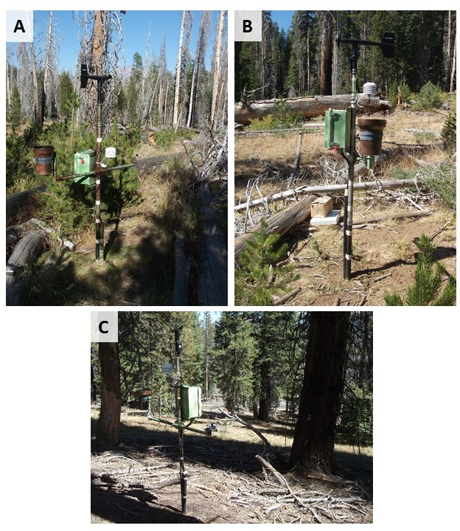

Figure B1: Images of weather stations in Sugarloaf Creek Basin. These stations are located in three nearby areas: one relatively wet site dominated by grasses and conifer recruitment (A; referred to as “wetland” in the main text), one drier site with sparse conifer recruitment and shrub growth (B; referred to as “shrub” in the main text), and one with an intact mature conifer canopy (C; referred to as “forest” in the main text).

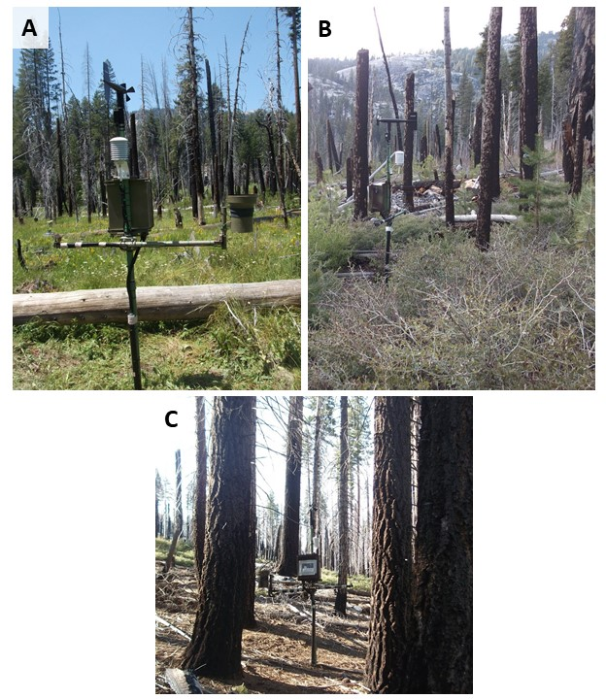

Figure B2: Images of weather stations in Illilouette Creek Basin. These sites are dominated by wetland vegetation (A; “wetland”), shrubs and conifer recruitment (B; “shrub”), and a mature conifer canopy (C; “forest”).

The weather stations reported more precipitation in ICB than SCB (Table B2), with the differences being larger (1.3-1.6 times more precipitation in ICB than SCB) in 2017 (a wet year) than 2018 (1.1-1.2 times more precipitation in ICB), a dry year. Precipitation totals for ICB are conservative for 2017 WY because of the removal of the weather stations prior to the Empire Fire (September through the end of November 2017). At least two precipitation events occurred during this time. Comparing the weather station precipitation estimates to PRISM data (<http://www.prism.oregonstate.edu>) at the same locations shows the same general trends in space and time, giving us confidence in our estimates of the relative differences in precipitation between the basins, even if the exact values do not agree (Table B2). PRISM precipitation is highly uncertain in the Sierra Nevada, and the differences in annual total precipitation do not indicate that ICB/SCB measurements are erroneous (Henn et al. 2018).

*Table B2. Annual precipitation estimates for water years (WY) 2016 through 2018. Weather station estimates are averaged between the non-forest stations at each watershed (ICB and SCB) as these stations should not experience interception losses. The ratio of precipitation between sites and between datasets show that for 2016-2018 ICB always received more annual precipitation than SCB (regardless of dataset), and PRISM always estimated higher precipitation than our weather stations.*

|  |  |  |  |
| --- | --- | --- | --- |
|  | **WY 2016** | **WY 2017** | **WY 2018** |
| Weather Station, ICB | 580 mm | 1130 mm | 560 mm |
| PRISM, ICB | 1028 mm | 2017 mm | 797 mm |
| Weather Station, SCB | NA | 780 mm | 490 mm |
| PRISM, SCB | 843 mm | 1491 mm | 673 mm |
| ICB/SCB, Weather Stations. | NA | 1.45 | 1.14 |
| ICB/SCB, PRISM | 1.22 | 1.35 | 1.19 |
| PRISM/Station, ICB | 1.77 | 1.78 | 1.42 |
| PRISM/Station, SCB | NA | 1.96 | 1.37 |

Most precipitation in both basins is in the form of snow, and the basins had different snowpack depths (Figure B3). Snow data in 2017 are incomplete for SCB because of periods of time when the snowpack covered the cameras. Nonetheless, we estimate that snow depth was similar between the two sites during the 2017 and 2018 WYs. In ICB manual snow depth measurements were taken in a grid around each weather station in March 2016, January and April 2017, and March 2018 (points and error bars on Figure B2 for ICB), but manual measurements were not made at SCB because the site was inaccessible in the winter. For both locations and all water years, the wetland station had the greatest snowpack depth and the latest melt date, and the forest station had the lowest snowpack depth and earliest melt date.

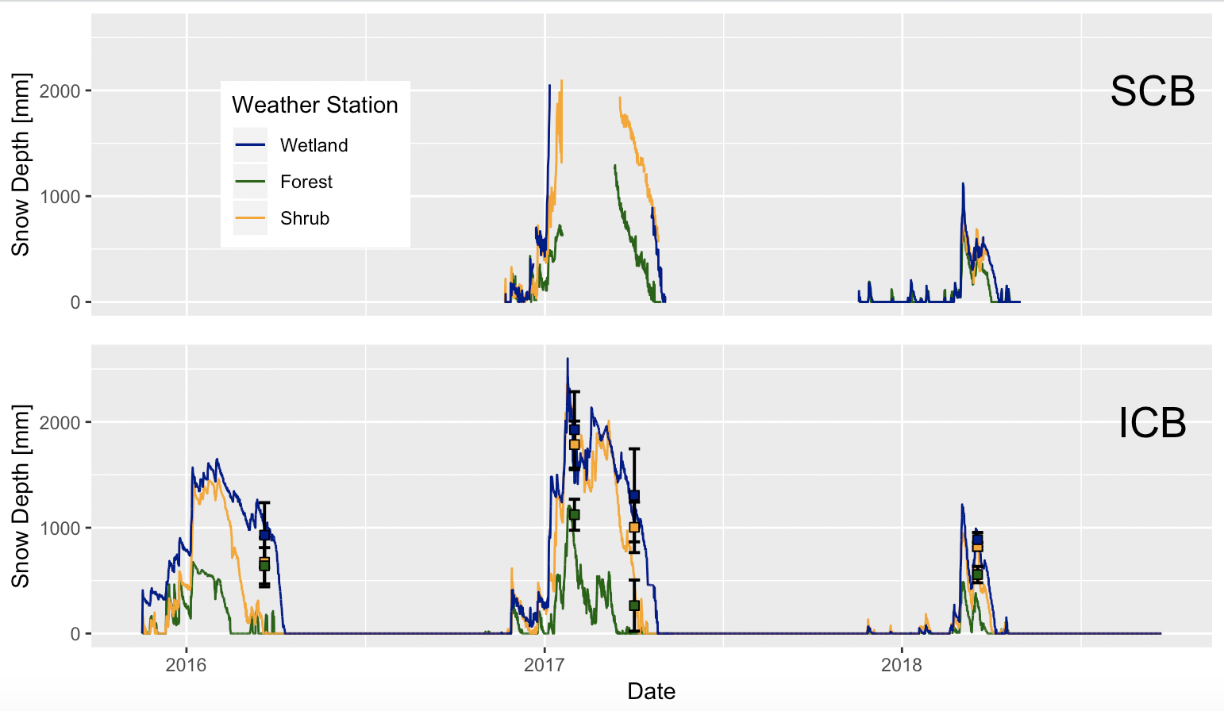

Figure B3: Snow depth (in mm) for Sugarloaf Creek Basin (top) and Illilouette Creek Basin (bottom) as measured from images taken four times each day at wetland, shrub, and forest weather station sites. Additionally, error bars (squares indicating mean, and bars indicating standard deviation) are shown for manually measured snow depths in ICB. In SCB, cameras were covered during peak snowpack for 2017-18 winter, resulting in missing data. Same winter shrub camera has stopped working before full snowmelt.

Appendix C: Details of landscape changes

**Methods:**

We used the FRAGSTATS package to calculate land cover metrics for ICB and SCB on vegetation maps created from images taken in 1973 and 2014 (SCB) and from images taken in 1969/70, 1987, 1997, 2005, and 2012 for ICB. For both watersheds, the first year of imagery (either 1973 or 1969/70) coincided with the end of a long period of fire suppression, and represents vegetation before the first fire in the managed wildfire era. The vegetation maps divided land cover into four vegetation classes: forest, shrub, sparse meadow, and dense meadow. For SCB, areas south of the southernmost extent of historical fires were removed from the landscape change analysis, since this area consisted mostly of isolated patches of vegetation surrounded by rock and caused misleading values (this was not necessary for ICB, which contained very little mapped vegetation in the rocky high-elevation areas). Isolated pixels surrounded by different vegetation types were removed from the maps before processing by merging them with the surrounding vegetation type, which minimized differences caused by small isolated patches that were likely due to classification error or would be difficult to capture the same way using two sets of imagery.

**Landscape Metrics:**

Diversity indices describe heterogeneity by measuring how patches of vegetation are distributed spatially across the landscape and capture fire-related landscape changes well (Romme 1982). We evaluated the following diversity metrics:

*Shannon’s Evenness Index* (SHEI) is the *Shannon’s Diversity Index* (calculated using information theory) divided by the maximum diversity given the number of cover types present (McGarigal et al. 2012). An evenness index of 1 means that all vegetation types are equally represented in the landscape; higher evenness indicates greater landscape diversity.

*Simpson’s Evenness Index* (SIEI) is similar, but is calculated using the probability that any two cells selected at random would be different patch types (McGarigal et al. 2012). Again, a value of 1 means all patch types cover an equal area, while a value near 0 means that one type dominated nearly all of the landscape. We include both evenness indices in order to verify that the exact method of calculating evenness does not affect our results.

*Aggregation Index* (AI) is a measure of how much each vegetation type is clumped into a few large groups (high aggregation) or spread into many small groups (low aggregation).

**Patch properties within each class:**

Patch properties describe local-scale heterogeneity and the size and shape of individual vegetation patches. For this study, we used metrics which have been shown to be consistent across many different landscapes (Cushman et al. 2008):

*Largest patch percent area* (LPI) gives the percent of the total vegetated area taken up by the largest contiguous vegetation patch within each vegetation class. This metric gives an idea of the maximum area dominated by a single type of overstory.

*Fractal dimension* (FRAC) measures how complex and plane-filling the shapes are by using the relationship between the area and perimeter of a patch. As the dimension approaches 2, perimeter is maximized for a given area of coverage, while for simple geometries such as squares or circles the dimension is 1 (McGarigal et al. 2012). For example: a vegetation class with a low fractal dimension whose largest patch covers a large area indicates a spatially homogeneous region. On the other hand, a high fractal dimension suggests an increase in the total length of boundaries between patches of different types, thus increasing local heterogeneity.

We also calculated the mean and standard deviation of the areas of all patches within each vegetation class. These measures help capture the changes in the distribution of patch sizes. All calculations were made on a rasterized vegetation map with a spatial resolution of 5 meters. This spatial resolution was chosen to match with calculations made on ICB vegetation (Boisramé et al. 2017b).

**Results and Discussion:**

Sugarloaf Creek Basin (SCB) showed a much smaller degree of landscape change than Illilouette Creek Basin (ICB). Diversity indices increased over time for both watersheds, but the change was negligible for SCB, showing that landscape diversity rose only very slightly in response to fire (Figure C1). The landscape-scale aggregation index increased slightly over time in SCB, in contrast to a decrease in ICB (Figure C2). This could be due to fires creating larger areas of sparse meadow that are more aggregated than pre-burn meadow areas (Figure C3b). The size of the largest vegetation patches did not vary appreciably in SCB between 1973 and 2014, with the exception of sparse meadows (Figure C3). The mean and standard deviation of patch sizes, however, showed similar trends to ICB (Figure C4). Most notably, conifer patches got smaller and less varied in size following 4 decades of fire (Figure C4). While fractal dimension increased for all vegetation types in ICB, it remained flat or decreased slightly in SCB (Figure C5). This may partially be due to fires creating a small number of new fairly homogeneous patches with simple geometries, but the small amount of change demonstrates that patch properties varied very little in response to fire in SCB.

Relative proportions of each vegetation type were similar between the two watersheds (Figure C6; note that these proportions do not account for exposed rock). Both watersheds also had similar Shannon’s Evenness Index values in their pre-fire/post-suppression states (Figure C1). These similarities show that, despite differences discussed in the main text, the large-scale land cover types and distributions are comparable between these watersheds, making them useful to use as two case studies demonstrating how fire affects two similar landscapes in areas with slightly different climatology and geology.

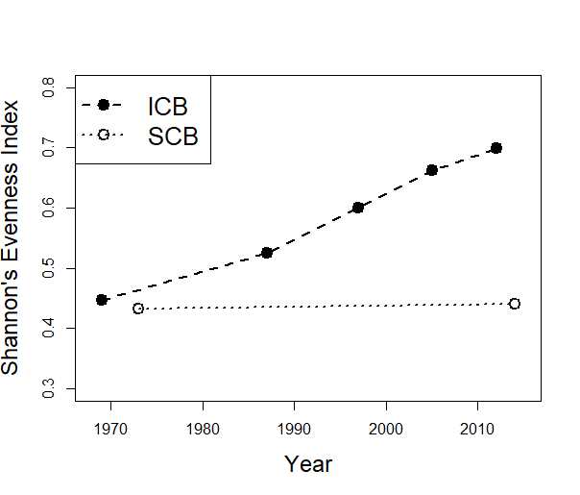

*Figure C1. Shannon’s Evenness Index calculated for both ICB and SCB for each year that we created vegetation maps from aerial imagery.*

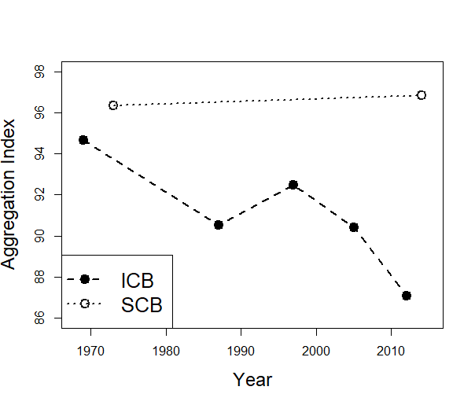

*Figure C2. Aggregation Index calculated for both ICB and SCB for each year that we created vegetation maps from aerial imagery.*

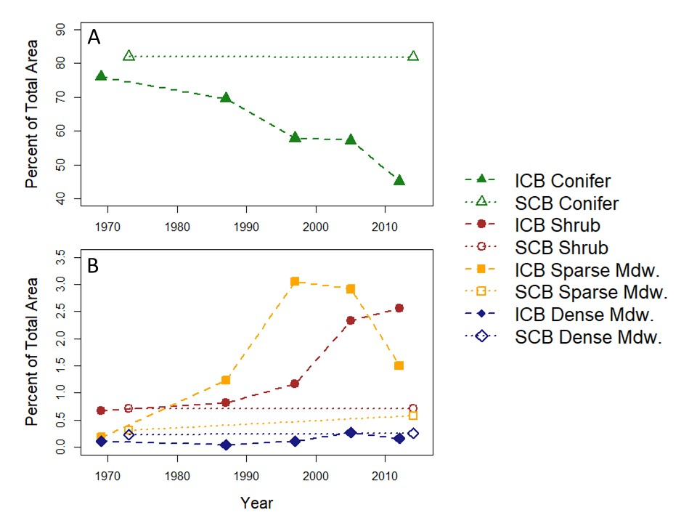

*Figure C3. Largest patch index (LPI; the percent of the total area occupied by the largest contiguous patch of vegetation) for each vegetation class for both ICB and SCB. Conifer (A) is shown separately from the other vegetation classes (B) due to large differences in scale.*

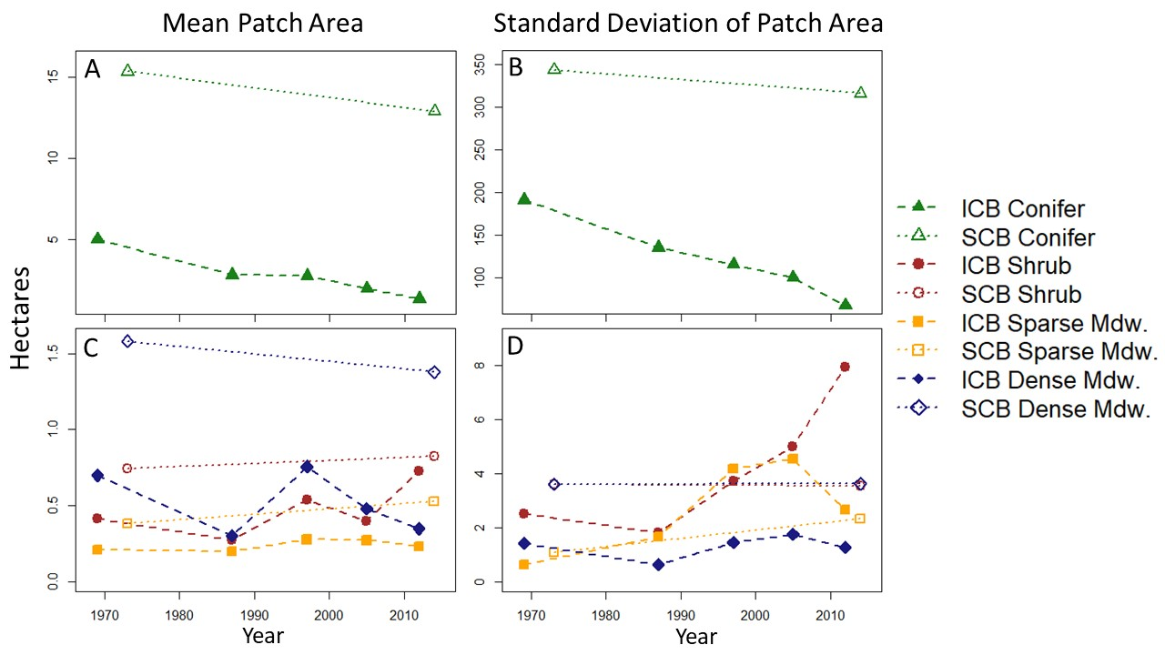

*Figure C4. Mean (A,C) and standard deviation (B,D) of patch size for each vegetation class for both ICB (dashed lines) and SCB (dotted lines). Conifer is shown separately (A,B) from the other vegetation classes due to large differences in scale.*

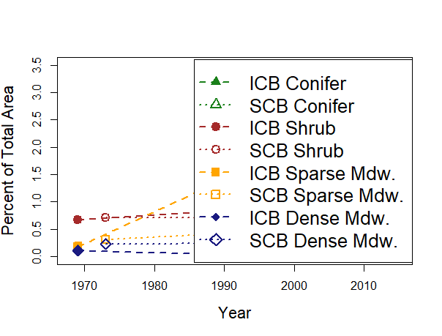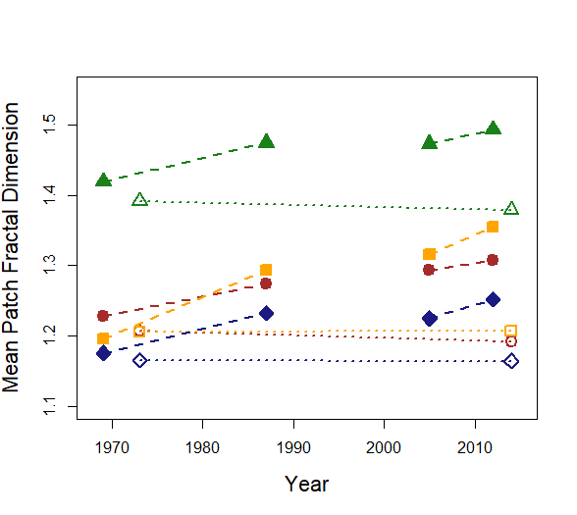

*Figure C5. Mean area-weighted fractal dimension of patches for each vegetation class for both ICB and SCB. 1997 is omitted due to small differences in mapping protocol affecting patch fractal dimension.*

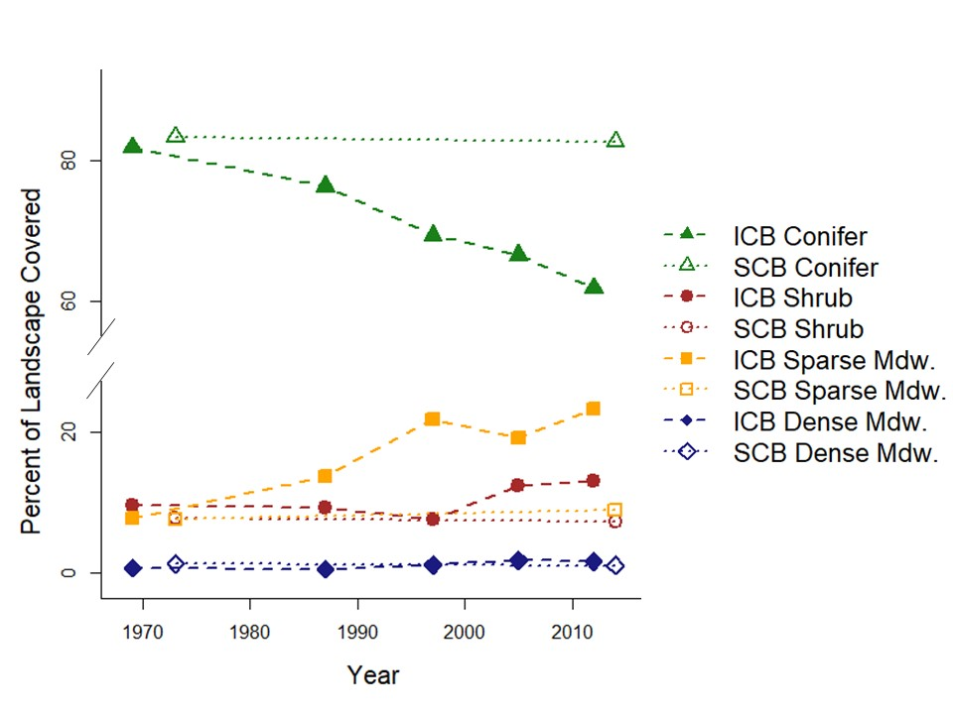

*Figure C6. Percent of the total vegetated area covered by each vegetation class for both ICB and SCB.*

# Appendix D: Detailed soil moisture model results

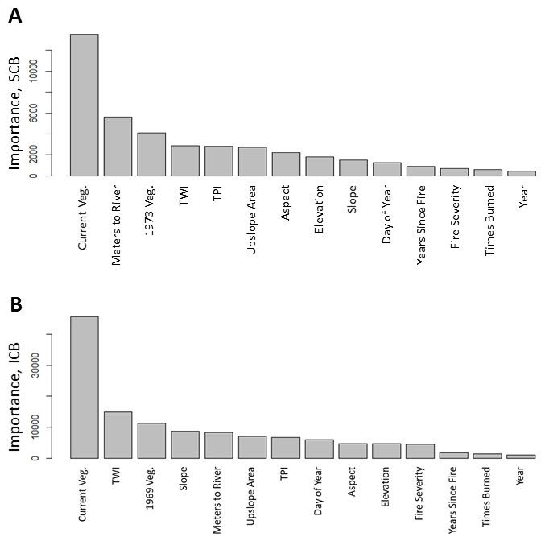

Figure D1: Relative importance of each variable in predicting plot-level soil moisture for Sugarloaf Creek Basin (A) and Illilouette Creek Basin (B). Variables include 2014 vegetation (Current Veg), Distance from nearest stream, 1973 vegetation, topographic wetness index at a 10m resolution (TWI), Upslope contributing area, topographic position index calculated at a scale of 300m (TPI), aspect, elevation, slope, maximum fire severity, days since January 1 for the measurement (Day of Year), years since fire, times burned, and year of the measurement.

*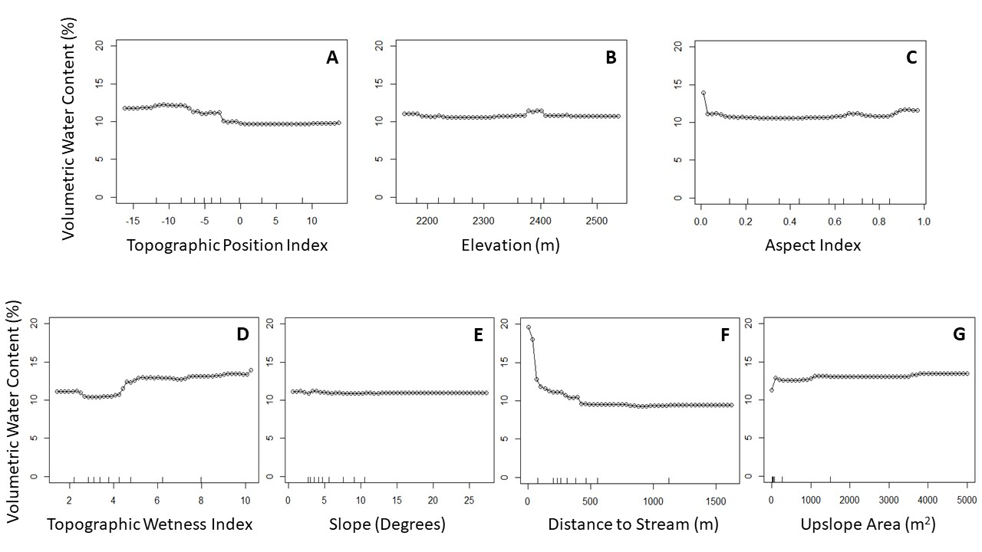Figure D2: Partial plots showing how the mean soil moisture (across all other possible variable values) varies with each topographic variable.*

*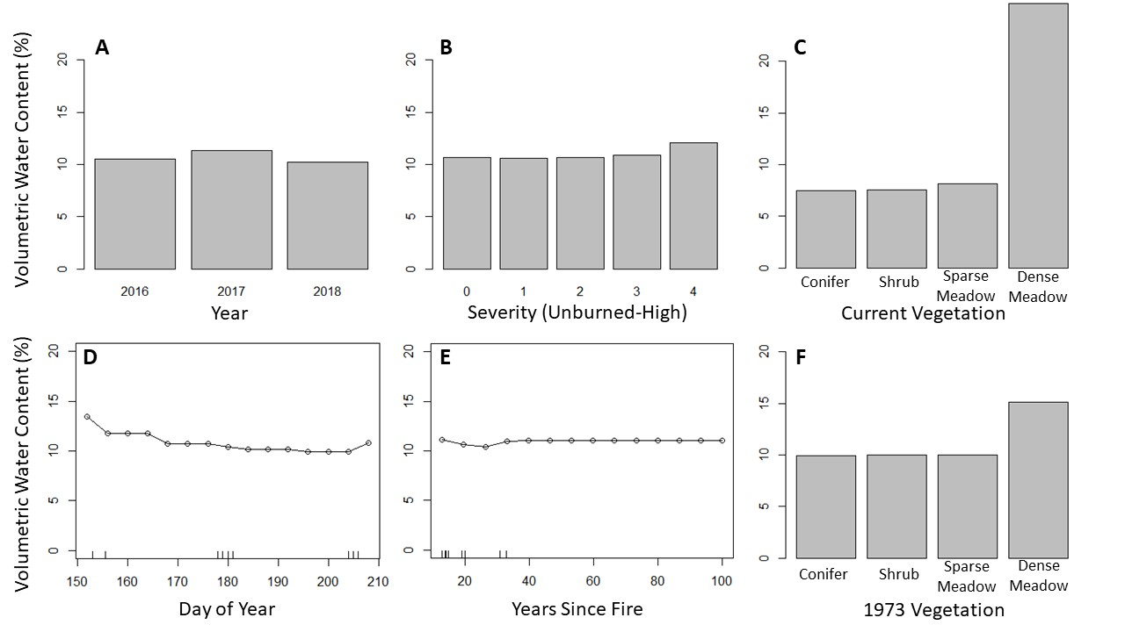Figure D3: Partial plots showing how the mean soil moisture (across all other possible variable values) varies with each variable. Those variables treated as factors rather than numbers in the model are shown as bar plots. Number of fires varied moisture by less than 0.4%, and is not shown.*

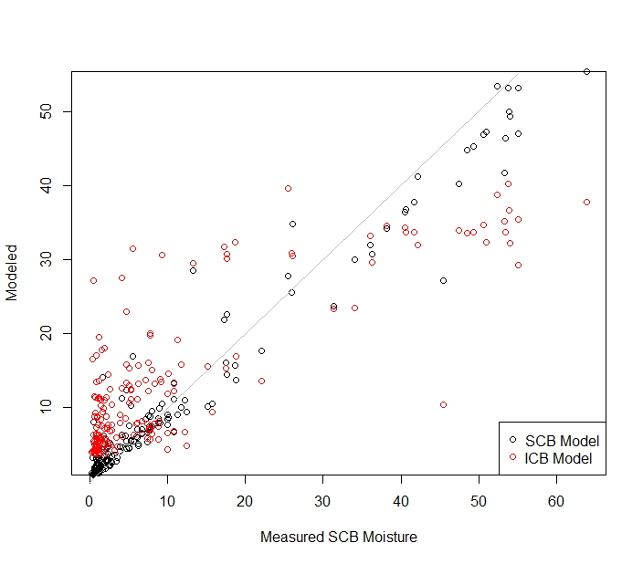

Figure D4. Modeled versus measured soil moisture in SCB (site means). Red points are calculated using a model trained on ICB data; black points are from a model trained on SCB data.

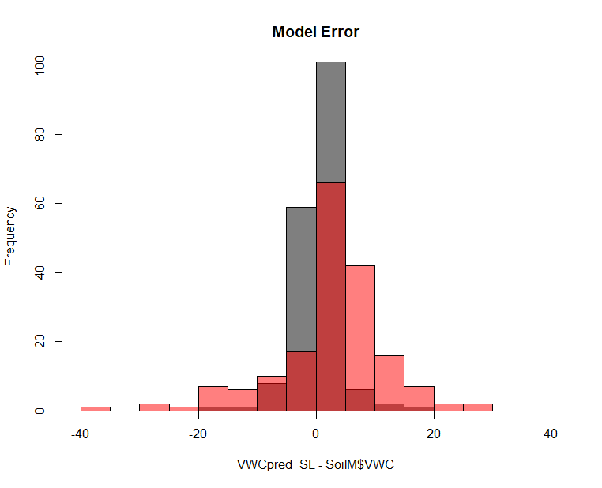

Figure D5. Errors in predicting SCB soil moisture using a model trained on SCB data (grey) and on ICB data (red).

**Literature Cited**

Boisramé, G. F. S., S. E. Thompson, M. Kelly, J. Cavalli, K. M. Wilkin, and S. L. Stephens. 2017b. Vegetation change during 40years of repeated managed wildfires in the Sierra Nevada, California. Forest Ecology and Management **402**:241-252.

Cushman, S. A., K. McGarigal, and M. C. Neel. 2008. Parsimony in landscape metrics: Strength, universality, and consistency. Ecological Indicators **8**:691-703.

Henn, B., A. J. Newman, B. Livneh, C. Daly, and J. D. Lundquist. 2018. An assessment of differences in gridded precipitation datasets in complex terrain. Journal of Hydrology **556**:1205-1219.

Little, R. J. A. 1988. Missing-data adjustments in large surveys. Journal of Business & Economic Statistics **6**:287-296.

McGarigal, K., S. A. Cushman, and E. J. Ene. 2012. FRAGSTATS v4: spatial pattern analysis program for categorical and continuous maps. Computer software program produced by the authors at the University of Massachusetts, Amherst. Available at the following web site: http://www.umass.edu/landeco/research/fragstats/fragstats.html.

Romme, W. H. 1982. Fire and landscape diversity in subalpine forests of Yellowstone National Park. Ecological Monographs **52**:199-221.